Review 2

Name: Parva Shah
Registration Number: 23BCE1282
Project Title: Brain Tumor Detection Using Convolutional Neural Networks (CNN)

1. Problem Statement
Brain tumors are life-threatening medical conditions that require early and accurate diagnosis. Currently, MRI scans are manually examined by radiologists, which can be time-consuming and subject to human error, especially when dealing with large volumes of medical images.
There is a need for an automated and reliable system that can assist medical professionals in identifying the presence of brain tumors from MRI scans. A deep learning-based detection system can reduce diagnostic time, improve consistency, and support early-stage detection. This project aims to develop a CNN-based model that can automatically classify MRI brain images as tumor or non-tumor with reliable accuracy.

2. Objectives
- To collect and preprocess MRI brain image datasets for model training.
- To implement image downscaling and normalization techniques for efficient computation.
- To design and train a Convolutional Neural Network (CNN) for tumor detection.
- To classify MRI images into tumor and non-tumor categories.
- To evaluate model performance using accuracy metrics.
- To prepare the foundation for future tumor segmentation and image enhancement techniques.

3. Methodology / Approach
The project follows a structured deep learning development approach:
Dataset Preparation: MRI brain images are collected and organized into tumor and non-tumor categories. The dataset is divided into training and testing sets.
Image Preprocessing: Images are downscaled to a fixed resolution to reduce computational complexity. Normalization techniques are applied to standardize pixel values and improve model performance.
Model Design: A CNN architecture is implemented using convolutional layers for feature extraction, pooling layers for dimensionality reduction, and fully connected layers for classification.
Model Training: The CNN model is trained on the preprocessed dataset using appropriate loss functions and optimization techniques over multiple epochs.
Prediction and Evaluation: The trained model produces a binary output indicating whether a tumor is present or not. Model performance is evaluated primarily using accuracy.

4. Work Completed So Far
- Completed dataset collection and organization into tumor and non-tumor classes.
- Implemented image downscaling to standardize input size and reduce computational load.
- Designed and implemented the CNN architecture for tumor classification.
- Successfully trained the model on the prepared dataset.
- Achieved binary classification output indicating tumor presence (Yes/No).
- Integrated accuracy calculation to evaluate model performance on test data.

5. Screenshots
- Training images
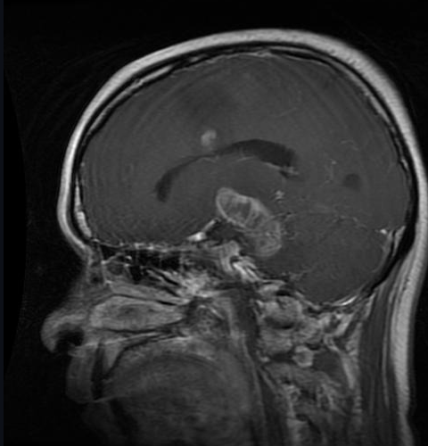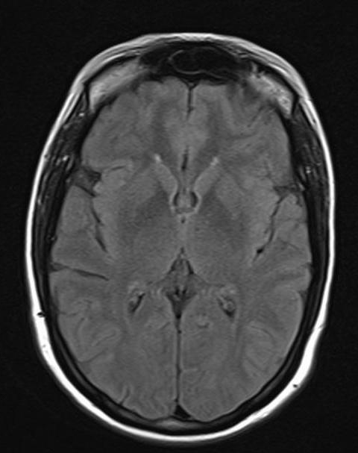
Tumorous Non-Tumorous

- Pre-processed image
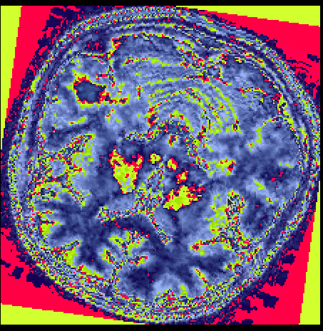
- Final output (accuracy and loss)
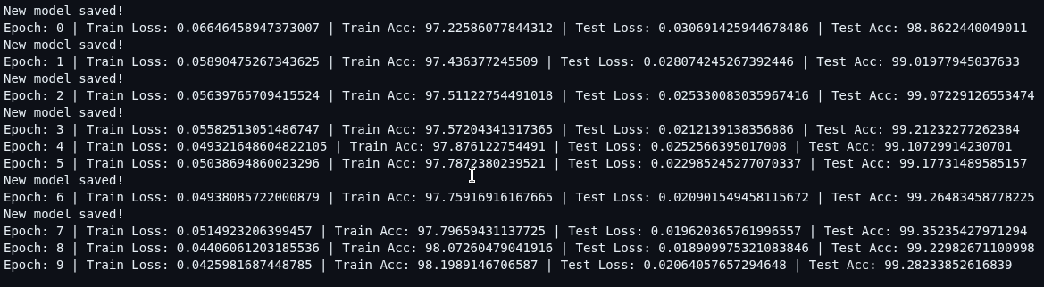

6. Future Plans
- Implement tumor segmentation to highlight the affected region in MRI scans.
- Generate segmented output images for better interpretability.
- Apply image upscaling techniques to enhance image resolution.
- Improve model performance through further optimization and tuning.
- Explore deployment options for real-time clinical usage.

Conclusion
The project has successfully established the foundational deep learning pipeline for automated brain tumor detection using CNN. The current implementation accurately classifies MRI images into tumor and non-tumor categories with measurable accuracy. Future work will focus on segmentation, image enhancement, and system refinement to make the solution more practical and clinically valuable.
Github link: https://github.com/parvashah-vit/D2_23BCE1282/tree/main

